**Infrasetup for Life ray application Procedure .**

A) We have downloaded life ray bundled from:

<https://www.liferay.com/downloads>

Apache tomcat version is: 8.0.32

Life ray version is: 7.0 - Life ray bundled is including apache tomcat and life ray application.

B) Unzip for life ray bundled package

unzip liferay-ce-portal-tomcat-7.0-ga2-20160610113014153.zip

C) Installed java according to the following url :

<http://tecadmin.net/install-java-8-on-centos-rhel-and-fedora/> - Blog

D) We have changed following files are.

# cd /opt

# cd liferay-ce-portal-7.0-ga2/

# cd tomcat-8.0.32/bin

**vi /etc/profile. –** The below lines are added end of file.

export JAVA_HOME=/opt/jdk1.8.0_91

export JRE_HOME=/opt/jdk1.8.0_91/jre

export PATH=$PATH:/opt/jdk1.8.0_91/bin:/opt/jdk1.8.0_91/jre/bin

**vi catalina.sh**

JAVA_HOME=/opt/jdk1.8.0_91

JRE_HOME=/opt/jdk1.8.0_91/jre

**Vi startup.sh**

export JAVA_HOME=/usr/local/java

export JRE_HOME=/usr/local/jdk

E) Started tomcat server by using startup.sh.

[root@ip-10-0-0-42 bin]# ./startup.sh

Using CATALINA_BASE: /opt/liferay-ce-portal-7.0-ga2/tomcat-8.0.32

Using CATALINA_HOME: /opt/liferay-ce-portal-7.0-ga2/tomcat-8.0.32

Using CATALINA_TMPDIR: /opt/liferay-ce-portal-7.0-ga2/tomcat-8.0.32/temp

Using JRE_HOME: /opt/jdk1.8.0_91/jre

Using CLASSPATH: /opt/liferay-ce-portal-7.0-ga2/tomcat-8.0.32/bin/bootstrap.jar:/opt/liferay-ce-portal-7.0-ga2/tomcat-8.0.32/bin/tomcat-juli.jar

Tomcat started.

[root@ip-10-0-0-42 bin]#

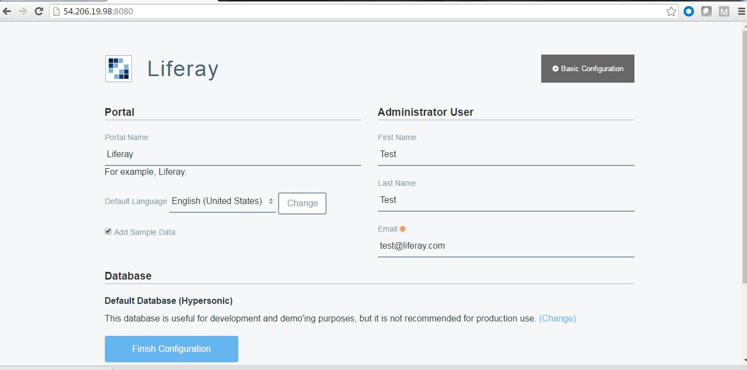

[root@ip-10-0-0-42 bin]# ./shutdown.sh

Using CATALINA_BASE: /opt/liferay-ce-portal-7.0-ga2/tomcat-8.0.32

Using CATALINA_HOME: /opt/liferay-ce-portal-7.0-ga2/tomcat-8.0.32

Using CATALINA_TMPDIR: /opt/liferay-ce-portal-7.0-ga2/tomcat-8.0.32/temp

Using JRE_HOME: /opt/jdk1.8.0_91/jre

Using CLASSPATH: /opt/liferay-ce-portal-7.0-ga2/tomcat-8.0.32/bin/bootstrap.jar:/opt/liferay-ce-portal-7.0-ga2/tomcat-8.0.32/bin/tomcat-juli.jar

[root@ip-10-0-0-42 bin]#

[root@ip-10-0-0-252 opt]# rpm -qa |grep -i mariadb

mariadb-5.5.47-1.el7_2.x86_64

mariadb-server-5.5.47-1.el7_2.x86_64

mariadb-libs-5.5.47-1.el7_2.x86_64

[root@ip-10-0-0-252 opt]#

[root@ip-10-0-0-252 opt]# systemctl enable mariadb

Created symlink from /etc/systemd/system/multi-user.target.wants/mariadb.service to /usr/lib/systemd/system/mariadb.service.

[root@ip-10-0-0-252 opt]# systemctl start mariadb

[root@ip-10-0-0-252 opt]# service status mariadb

The service command supports only basic LSB actions (start, stop, restart, try-restart, reload, force-reload, status). For other actions, please try to use systemctl.

[root@ip-10-0-0-252 opt]# systemctl status mariadb

● mariadb.service - MariaDB database server

Loaded: loaded (/usr/lib/systemd/system/mariadb.service; enabled; vendor preset: disabled)

Active: active (running) since Thu 2016-08-11 02:20:31 EDT; 48s ago

Process: 9289 ExecStartPost=/usr/libexec/mariadb-wait-ready $MAINPID (code=exited, status=0/SUCCESS)

Process: 9210 ExecStartPre=/usr/libexec/mariadb-prepare-db-dir %n (code=exited, status=0/SUCCESS)

Main PID: 9288 (mysqld_safe)

CGroup: /system.slice/mariadb.service

├─9288 /bin/sh /usr/bin/mysqld_safe --basedir=/usr

└─9447 /usr/libexec/mysqld --basedir=/usr --datadir=/var/lib/mysql --plugin-dir=/usr/lib64/mysql/plugin --log-error=/var/log/mariadb/mariadb.log --pid-fil...

Aug 11 02:20:29 ip-10-0-0-252.ap-southeast-2.compute.internal mariadb-prepare-db-dir[9210]: which will also give you the option of removing the test

Aug 11 02:20:29 ip-10-0-0-252.ap-southeast-2.compute.internal mariadb-prepare-db-dir[9210]: databases and anonymous user created by default. This is

Aug 11 02:20:29 ip-10-0-0-252.ap-southeast-2.compute.internal mariadb-prepare-db-dir[9210]: strongly recommended for production servers.

Aug 11 02:20:29 ip-10-0-0-252.ap-southeast-2.compute.internal mariadb-prepare-db-dir[9210]: See the MariaDB Knowledgebase at http://mariadb.com/kb or the

Aug 11 02:20:29 ip-10-0-0-252.ap-southeast-2.compute.internal mariadb-prepare-db-dir[9210]: MySQL manual for more instructions.

Aug 11 02:20:29 ip-10-0-0-252.ap-southeast-2.compute.internal mariadb-prepare-db-dir[9210]: You can start the MariaDB daemon with:

Aug 11 02:20:29 ip-10-0-0-252.ap-southeast-2.compute.internal mariadb-prepare-db-dir[9210]: cd '/usr' ; /usr/bin/mysqld_safe --datadir='/var/lib/mysql'

Aug 11 02:20:29 ip-10-0-0-252.ap-southeast-2.compute.internal mysqld_safe[9288]: 160811 02:20:29 mysqld_safe Logging to '/var/log/mariadb/mariadb.log'.

Aug 11 02:20:29 ip-10-0-0-252.ap-southeast-2.compute.internal mysqld_safe[9288]: 160811 02:20:29 mysqld_safe Starting mysqld daemon with databases from /var/lib/mysql

Aug 11 02:20:31 ip-10-0-0-252.ap-southeast-2.compute.internal systemd[1]: Started MariaDB database server.

[root@ip-10-0-0-252 opt]#

[root@ip-10-0-0-252 /]# mysql -u root -p

Enter password:

Welcome to the MariaDB monitor. Commands end with ; or \g.

Your MariaDB connection id is 2

Server version: 5.5.47-MariaDB MariaDB Server

Copyright (c) 2000, 2015, Oracle, MariaDB Corporation Ab and others.

Type 'help;' or '\h' for help. Type '\c' to clear the current input statement.

MariaDB [(none)]>

MariaDB [(none)]> create database liferay1

-> ;

Query OK, 1 row affected (0.00 sec)

MariaDB [(none)]> show databases

-> ;

+--------------------+

| Database |

+--------------------+

| information_schema |

| liferay1 |

| mysql |

| performance_schema |

| test |

+--------------------+

5 rows in set (0.00 sec)

MariaDB [(none)]> use liferay1;

Database changed

MariaDB [liferay1]> show databases;

+--------------------+

| Database |

+--------------------+

| information_schema |

| liferay1 |

| mysql |

| performance_schema |

| test |

+--------------------+

5 rows in set (0.00 sec)

MariaDB [liferay1]>

MariaDB [liferay1]> create table liferay2(id int(30), name varchar(40),address varchar(40));

Query OK, 0 rows affected (0.00 sec)

MariaDB [liferay1]> insert into liferay2(10,"chandra","liferay");

ERROR 1064 (42000): You have an error in your SQL syntax; check the manual that corresponds to your MariaDB server version for the right syntax to use near '10,"chandra","liferay")' at line 1

MariaDB [liferay1]>

MariaDB [liferay1]> insert into liferay2 values(10,"chandra","liferay");

Query OK, 1 row affected (0.00 sec)

MariaDB [liferay1]> select * from liferay2

-> ;

+------+---------+---------+

| id | name | address |

+------+---------+---------+

| 10 | chandra | liferay |

+------+---------+---------+

1 row in set (0.00 sec)

MariaDB [liferay1]>

[root@ip-10-0-0-42 logs]# vi catalina.out

[root@ip-10-0-0-42 logs]# cd ..

[root@ip-10-0-0-42 tomcat-8.0.32]# ls

1 bin conf lib LICENSE logs NOTICE RELEASE-NOTES RUNNING.txt temp webapps work

[root@ip-10-0-0-42 tomcat-8.0.32]# cd webapps/ROOT

[root@ip-10-0-0-42 ROOT]# ls

dtd errors html index.jsp layouttpl WEB-INF

[root@ip-10-0-0-42 ROOT]#

256 cd ../logs

257 tailf catalina.out